The Vikings

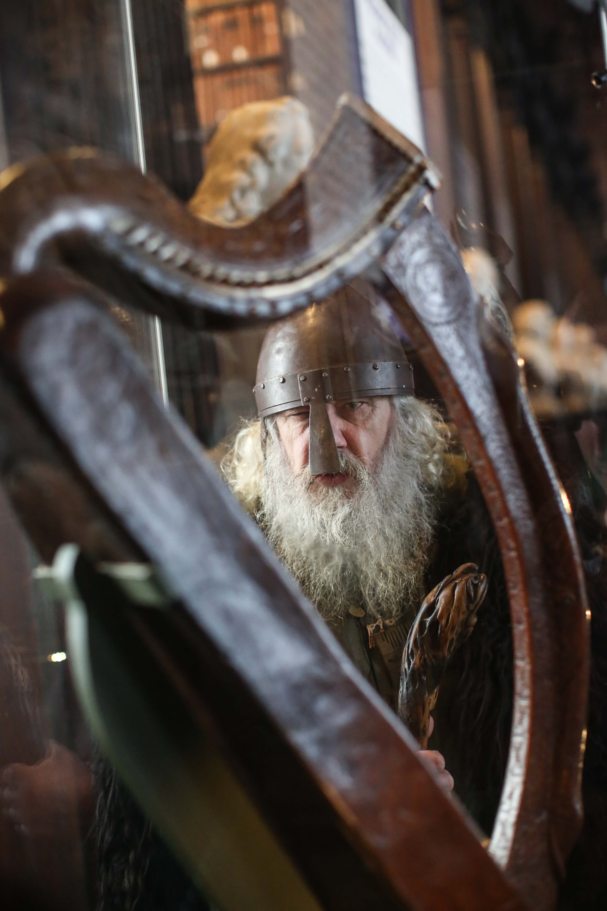

THE VIKINGS: VISITING THE PAST KS2
THE VIKINGS ON TRIAL KS2

EDUCATION PACK

Welcome to the Education Department of Armagh City, Banbridge and Craigavon Council.

Thank you for choosing to visit us at the Navan Centre & Fort. Our KS1 programme: Food in the Past along with our KS2 programme: from Stone Age to Early Christian Dwelling

Our department has been offering a wide range of programmes throughout the Council area and beyond since 1992 and currently provides workshops from Foundation Stage to GCSE at the Navan Centre and our second site: the Palace Stables

Please see below a list of some of our programmes:

Apple Week  (Incorporating National Apple Day) | KS1 and 2 | Palace Stables
Viking Festival of Fire | KS2 | Navan Centre
Winter Ecology Week | KS1 and 2 | Palace Stables
Christmas through the Ages | KS1 and 2 | Palace Stables
World War 2 | KS1 | Palace Stables
Boxes in the Attic  (Victorian) | KS1 and 2 | Palace Stables
Egyptians | KS2 | Navan Centre
Science Week | KS1, 2 and 3?? | Navan Centre
Food in the Past (Celtic) | KS1 | Navan Centre
Our Senses Month | KS1 | Palace Demesne
Orienteering Festival | KS2, 3 and GCSE | Palace Demesne
General Education-  Tree Tales/Summer Ecology/Storytelling/Orienteering etc… | KS1/2 | Palace Demesne
Learning from the Past (Celts) | KS1/2 | Navan

If you wish to book any of the above, please email us at: education@armaghbanbridgecraigavon.gov.uk

The Education Department offers two programmes based on the Vikings and Monks

Visiting the Past –the Vikings and the Monks Key Stage 2

This activity involves an exploration of Early Christian Ireland by examining the impact of both Monastic and Viking cultures.
Firstly, students encounter real life Vikings in the person of our Living History interpreters and visit a Viking trading post, look at Viking weaponry and way of life. Students have the opportunity to act out a Viking shield wall.
Pupils then have the chance to dress up as monks and, using quills and ink, practice writing as scribes. They learn about the legacy left by St Patrick and the Book of Armagh written by the monks in Armagh at the time of the first Viking invasions. This workshop concludes with a comparison with ancient Runic writing as children make a Viking craft (bookmark).
Finally, students will flesh out their knowledge of the Vikings and Monks by participating in a workshop involving a timeline activity and a time capsule.

Visiting the Past –the Vikings and the Monks Key Stage 2

This activity involves an exploration of Early Christian Ireland by examining the impact of both Monastic and Viking cultures.
Firstly, students encounter real life Vikings in the person of our Living History interpreters and visit a Viking trading post, look at Viking weaponry and way of life. Students have the opportunity to act out a Viking shield wall.
Pupils then have the chance to dress up as monks and, using quills and ink, practice writing as scribes. They learn about the legacy left by St Patrick and the Book of Armagh written by the monks in Armagh at the time of the first Viking invasions. This workshop concludes with a comparison with ancient Runic writing as children make a Viking craft (bookmark).
Finally, students will flesh out their knowledge of the Vikings and Monks by participating in a workshop involving a timeline activity and a time capsule.

Character Biography

Personal Details
Name | Olaf Olafson
Age | 50
Date of Birth | High Summer
Place of Birth | Ravndal Village
Position in Society | Shipwright
Religion | Norse Gods and Goddesses
Income | High
Abode | Ravndal Village
Family Details
Father  Name, Age, Position in society, Abode | Olaf Rolloson, Deceased, Shipwright
Mother  Name, Age, Position in society, Abode | Helga Sunedottir, Deceased, Wife of a Shipwright
Brothers/ Sisters  Name, Age, Position in society, Abode | N/A
Spouse  Name, Age, Position in society, Abode | N/A
Children  Name, Age, Position in society, Abode | N/A

Personality Traits
At his work, Olaf is a perfectionist. When fighting however, he is a merciless combatant and seeks to impart the worst suffering he can on his enemies.

Religious Beliefs
Like Most Norse people, Olaf believe and worships the many Gods and Goddesses. As a shipwright, he will particularly focus on the gods of the sea.

Position in Society (further details)
As a shipwright Olaf is well respected and much sought after for his kill and knowledge.

Character Biography

Personal Details
Name | Vilk ‘The Vicious’ Vidarson
Age | 36
Date of Birth | Mid- Winter
Place of Birth | Norway
Position in Society | Jarl
Religion | Norse Gods and Goddesses
Income | Substantial
Abode | Ravndal village, Norway
Family Details
Father  Name, Age, Position in society, Abode | Vidar Ragnarson, Deceased, Former Jarl
Mother  Name, Age, Position in society, Abode | Astrid Arnedottir, 55, late-Jarl’s wife.  Astrid lives in Ravndal village with her Son and his family
Brothers/ Sisters  Name, Age, Position in society, Abode | Yrsa Vidardottir, 34, Wife of Njal the Blacksmith  Yrsa lives in Ravndal village with her husband and their family
Spouse  Name, Age, Position in society, Abode | Sif Ulfdottir, 30, Jarl’s wife.  Sif lives in Ravndal village with her husband and family
Children  Name, Age, Position in society, Abode | Arne Vilkson, 13  Revna Vilkdottir, 11  Tove Vilkdottir, 11

Personality Traits
Vilk is a serious man, who holds himself together when leading his people. However when raiding he enjoys nothing more than cutting loose and indulging in the thrill of battle.

He is disgusted with the Monks lack of will to fight. For he believes if you won’t fight to save your life, then it wasn’t much of a life to begin with.

Religious Beliefs
Vilk has a deep respect and knowledge of the gods and is always careful to remember their place and what must be done to appease them

Position in Society (further details)
As Jarl in Ravndal, Vilk and his family enjoy the heights of luxury that such a position can bring. But learning from his late father, the former Jarl, this must be paid for in strength, honour, and blood.

INTRODUCTION TO THE VIKINGS AND MONKS

What people in history do you think you have come to learn about today?

- Vikings
- Monks

Who were the Vikings?

- Raiders, invaders but also farmers seeking land

Where did they come from?

- From Scandinavia or Norway (The Norse); Denmark; Finland and Iceland

When did they invade Ireland?

- In 795 AD

What does A.D. mean?

- Anno Domini (In the name of the Lord)

What transport did they use to arrive here?

- Longships

Who was not happy to see the arrival of the Norse?

- The Monks

What is a monk?

- A scribe or holy man

Where did monks live?

- Monasteries

Today, you will be doing 3 activities

Meet with two Vikings in their settlement
Find out about the monks and their Book of Armagh, visit a scriptorium and write as a monk while later making a Viking craft
Participate in a workshop and classify artefacts which belong to Vikings and Monks

Viking Workshop

Ask children what peoples they have been studying in school, and are going to learn more about today?

- Vikings

Get Pupils to close their eyes and visualize a Viking?

- Hair
- Clothing
- Weapons
- Longboats

Were all Vikings warriors and male?

- No, women fought also

What Countries did they raid?

- England
- Scotland

When?

- 793 AD – Lindisfarne
- 795 AD – Ireland

Why would the Vikings want to leave their homeland and raid other countries?

- Climate
- Un-fertile Land/Mountains
- Looking for better living standard

Were all Vikings warriors? Who was head of Viking society?

- King
- Earl/Chieftains (Land lords)
- Freemen (Craftsmen/Sailors/Traders)
- Slaves or Thralls

How would the Vikings travel to Ireland in 795AD?

Longboat (Show longboat)

- Oak Panels/Rope/Animal Hair
- Tar from Pine Trees (Waterproof)
- Dragon Head

- Longboat also able to travel on Inland Rivers?
-Display map of Ireland –Show Shape, inlets/Fjords

- Name towns ending with Ford
-What do we need to drink?
-Water – Ford
-Opposite of short?
-Long – Ford

- Were the Vikings Christian?

Name their gods
Odin – God of gods – Magic/Poetry
Loki – Trickster
Thor – God of Sky/Storms/Thunder
Thor’s Hammer – Symbol of protection

- In Ireland who did the Vikings meet?

Monks

- Where did they live?

Monasteries

- Show picture of monastery

Round houses
Scriptorium
High Tower

Discuss and ask pupils to hold and answer the questions from the artefacts in a time capsule

Thor’s hammer, amber necklace, quill, sun stone, sun compass, wax tablets, leather shoes, braiding, chainmail, cow horn, Christian cross etc

Name:
DIRECTIONS: Write the number of the vocabulary word in the box next to the corresponding definition.
Exploring World History

The Vikings

ODirect a ship.
Ax
Berserker
Wilk
Erikson
Expedition
Fjord
Hammer
Hoard
Horns
Long Ship
Navigate
Norse
Odin
Sacrifice
Plunder
Raid
Raven
Runes
Scandinavia
Seafarer
Shield
Thor
Valhalla
Warrior
OName for boat used by Vikings.
ORelating to medieval Scandinavia.
The Vikings who came to Ireland were called the Norse.
They raided the monastery in Armagh in 832 AD and three times in the following ten years
OName of heaven in Norse mythology.
OJourney of exploration.
OPossible weapon for a Viking.
OThe Viking flag featured this bird that sat on Odin's throne.
OSteal by force. OWarrior god of thunder. OSudden hostile attack. OViking alphabet.
OContrary to legend, Vikings did not wear these on their heads.

Did You Know?

ONorse explorer who reached North America before Columbus.
OLong, narrow inlet of the sea between cliffs.
ONorse god who oversees Valhalla. OKilling a slave for the gods.
OCollection of treasure.
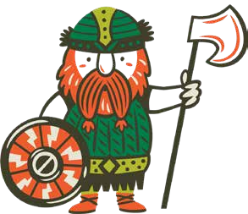
OThor's weapon of choice.
OBrave fighter.
OName of Viking warrior you met today
OA very skilled and dangerous Viking warrior.
ORegion of Northern Europe including Denmark, Norway, Sweden.
OImportant protection for a warrior.
OSomeone who works or travels on a boat

Name ___________________________ Class _____ Date _____________

The Vikings - Fact or Opinion?

Many hundreds of years ago people known as Vikings lived in Norway, Sweden and Denmark. They were farmers, but their land was not very good for farming. They could not always grow enough food to feed themselves. So the Vikings had to find new countries to settle in.

The Vikings loved adventure. They set sail in their long ships to find new lands. As well as travelling to Britain, they reached North America, Russia, Iceland and Greenland.

For over 300 years the Vikings attacked and raided other countries. They were often very cruel to their enemies and many people lived in fear for their lives. They once attacked and destroyed the monastery at Lindisfarne, in the north of England. They even besieged Paris in AD 885.

The Vikings were fierce warriors. They fought with swords, battle axes and spears. Some axes were so heavy that they had to be lifted with two hands. They also used large, round shields.

Read the sentences below and write “fact” or “opinion” next to each one.

- The Vikings came from Norway, Sweden and Denmark. ____________
- The Vikings were not very good at farming. ___________
- They could not grow enough food to feed themselves. _________
- The Vikings enjoyed being farmers. ____________
- Viking boats were called longships. ___________
- The Vikings travelled as far as North America. ____________
- They loved attacking and raiding other countries. ___________
- They were often very cruel to their enemies. _____________
- Everyone hated the Vikings. ________________
- Lindisfarne is in the north of England. ___________
- Square shields would have been better than round ones. ____________
- They fought with swords, battle axes and spears. ____________
- Some axes were so heavy that they had to be lifted with two hands. ___

Look at the alphabet above. Can you write your name on the lines below?

______________________ ____________________________

Answer the questions below by using the magic runes?

Who are the people who used the runic alphabet?

The _____________________

Where did the Vikings come from? (one word)

__________________________

Why did the come to your country?

The Viking Long ship

Use the internet to find the answers to the following questions

1 What features of the longship would allow it to go fast?

2 Why would speed be important for a Viking longship?

3 What was the main power source for the longship? The sail or the oars? Why?

4 Which feature of the ship controls its direction?

5 What clues on the ship tells you that it was used for war?

6 How many people would have been on board? What did they all do?

7 Do you think that the picture is of a longship at sea or in harbour?

8 Is the prow (front) or the stern (back) nearest you in the picture?

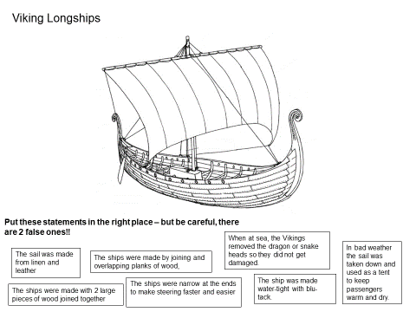
Villages

Describe a typical Viking village.
____________________________________________________________________________

What did their houses look like?
____________________________________________________________________________

Clothes

Describe the clothes that a Viking man or woman wore.
____________________________________________________________________________

What did their shoes look like?
______________________________________

Food
Describe what typical Viking food would have been.
____________________________________________________________________________
____________________________________________________________________________

Jobs

What jobs would the Vikings have done? Describe the jobs men and women would do.
__________________________________________________________________________________________________________________

What did the children do?
__________________________________________________________________________________________________________________

Imagine that you are a Viking warrior preparing for your first raid. Describe your thoughts and feelings as you are about to step onto the long ship

Use the word bank below as a guide

Scared
Apprehensive
Fearless
Honour
Duty
Bloodthirsty
Drowning
Dragon
Sails
Weapons

________________________________________________________________________________________________________________________________________________________________________________________________________________________________________________________________________________________________________________________________________________________________________________________________________________________________________________________________________________________________________________________________________________________________________________________________________________________________________________________________________________________________________________________________________________________________________________________________________________________________________________________________________________________________________________________________________________________________________________________________________________________________________________________________________________________________________________________________________________________________________________________________________________________________________________________________________________________________________________________________________________________________________________________________________________________________________________________________________________________________________________________________________________________________________________________________________________________________________________________________________________________________________________________________________________________________________________________________
Do you know your Weapons?

You saw these weapons during your visit!
Can you match the weapon to their name?
BATTLE AXE SEAX BOW SHEILD SWORD SPEAR
BEARDED AXE

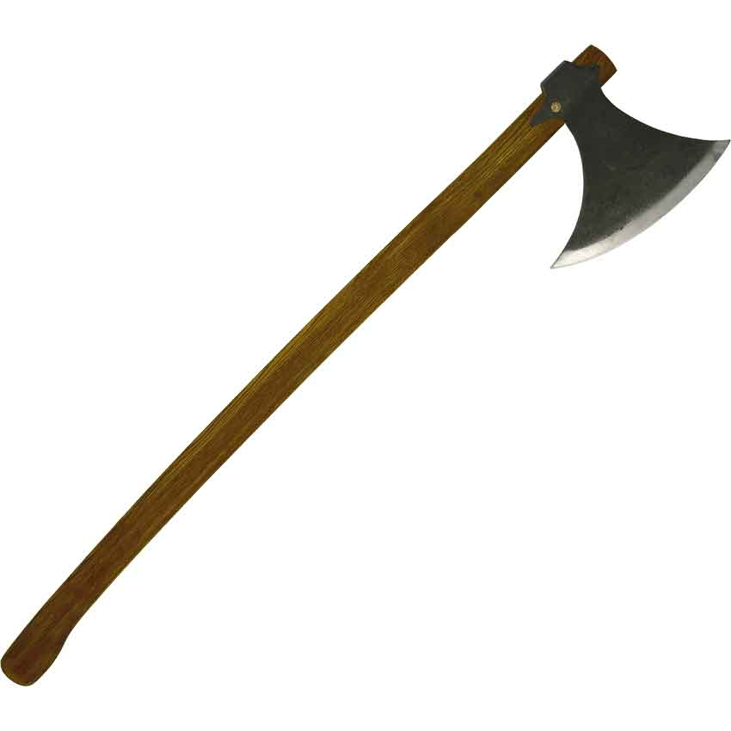

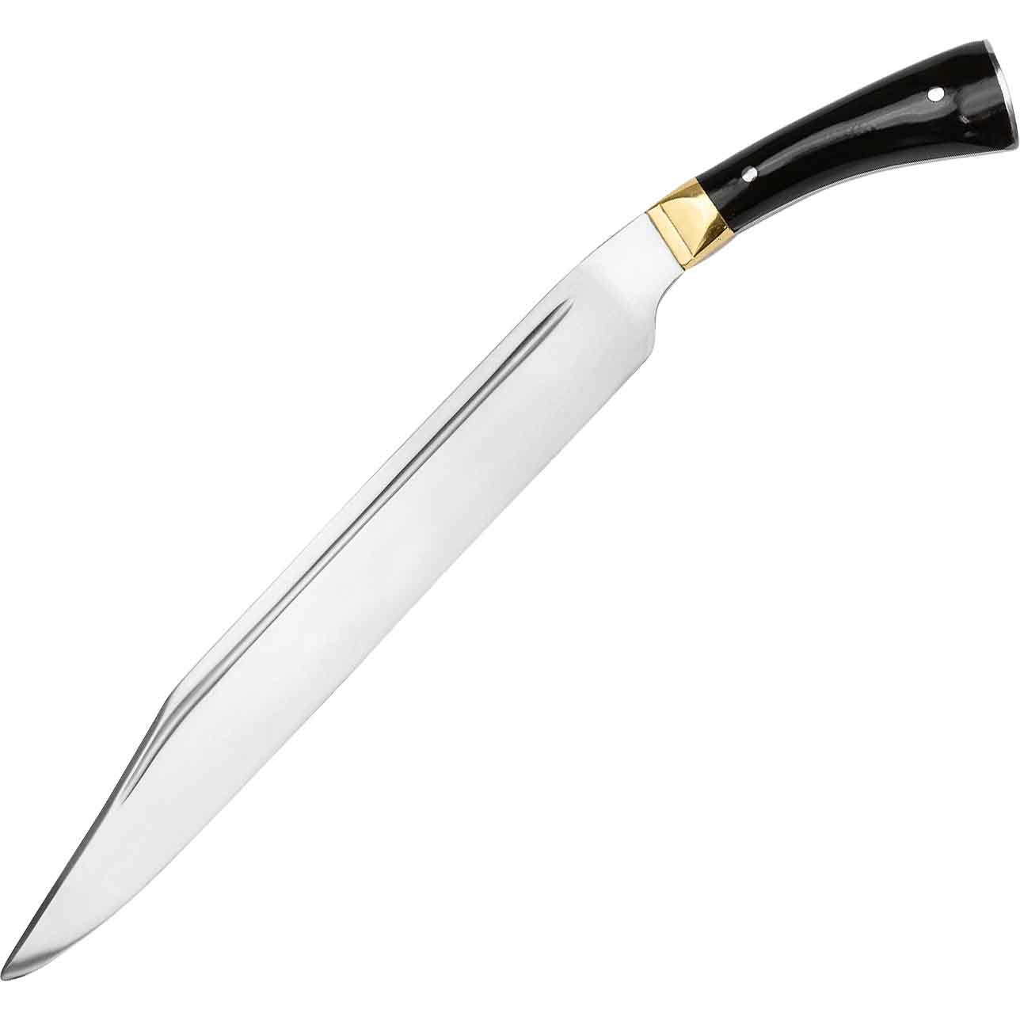
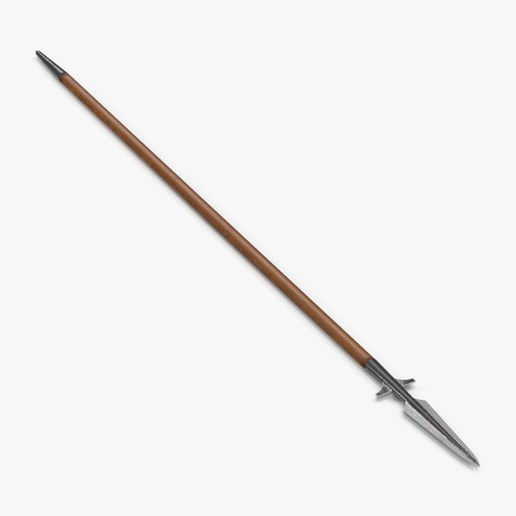

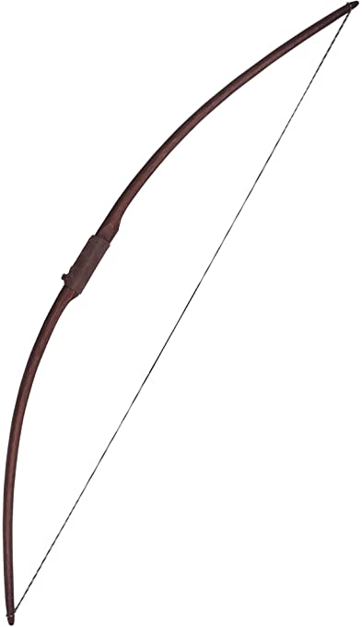

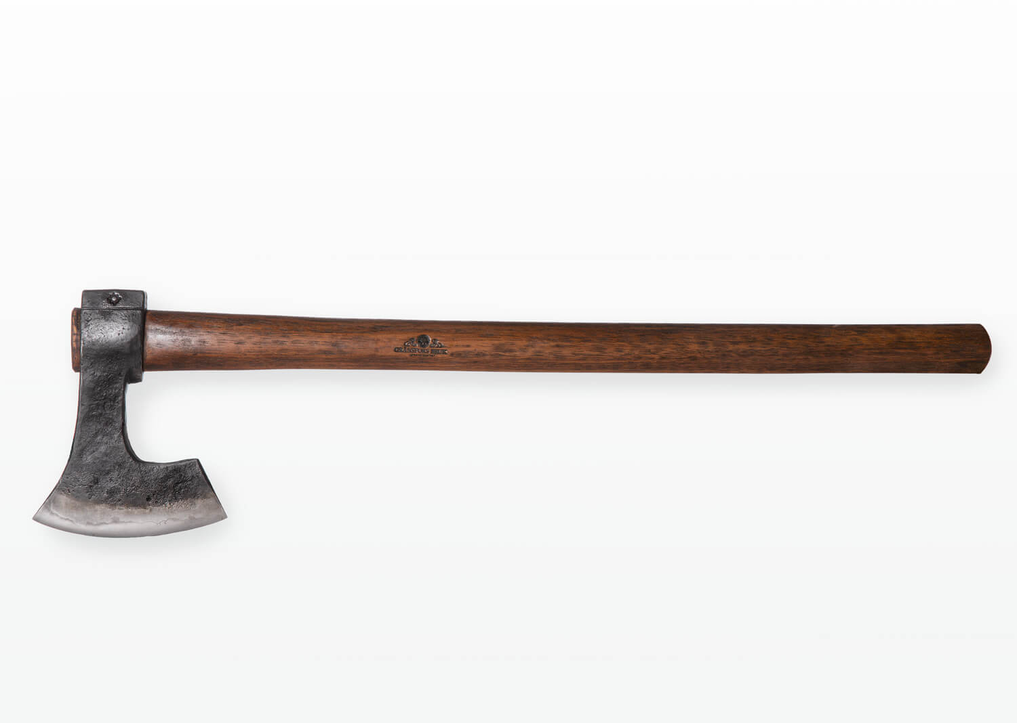

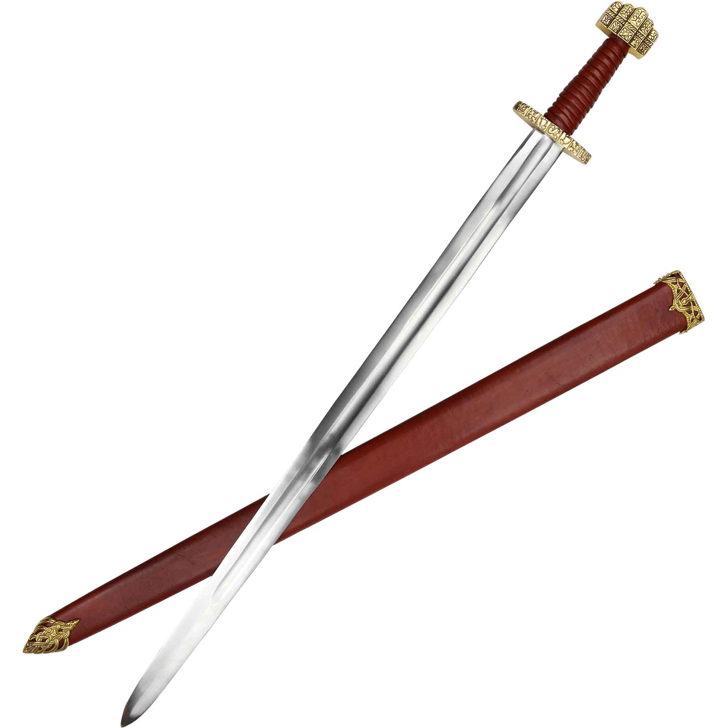

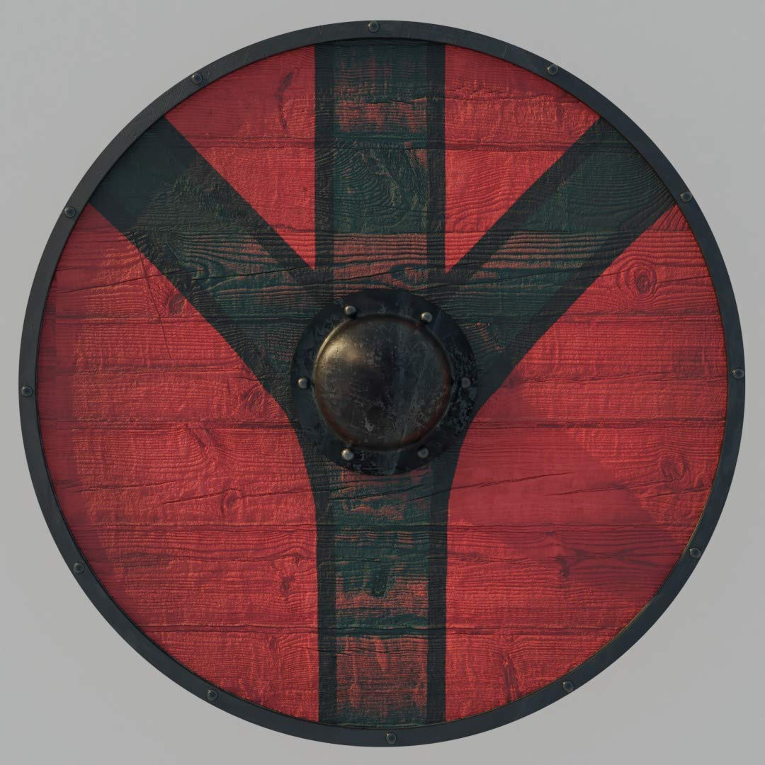

Viking Word Search!

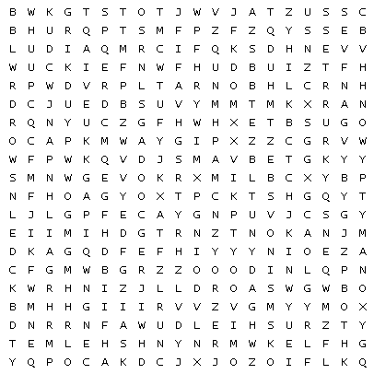

Axe Shield Thor Freya

Helmet Sword Odin

Spear Chainmail Tyr

