**THE CELTS**

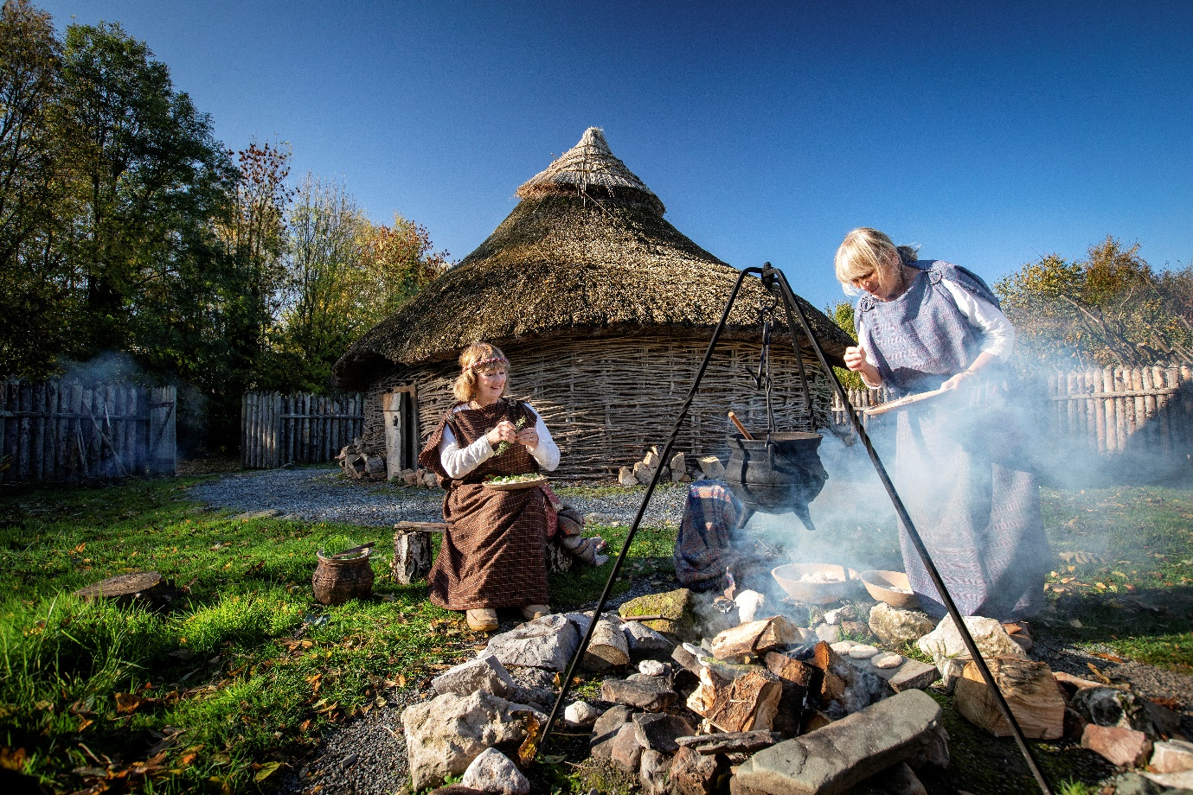

FOOD IN THE PAST KS1

FROM STONE AGE TO EARLY CHRISTIAN DWELLING KS2

EDUCATION PACK

Welcome to the Education Department of Armagh City, Banbridge and Craigavon Council.

Thank you for choosing to visit us at the Navan Centre & Fort. Our KS1 programme: Food in the Past along with our KS2 programme: from Stone Age to Early Christian Dwelling

Our department has been offering a wide range of programmes throughout the Council area and beyond since 1992 and currently provides workshops from Foundation Stage to GCSE at the Navan Centre and our second site: the Palace Stables

Please see below a list of some of our programmes:

|  |  |  |
| --- | --- | --- |
| **Apple Week**  **(Incorporating National Apple Day)** | **KS1 and 2** | **Palace Stables** |
| **Viking Festival of Fire** | **KS2** | **Navan Centre** |
| **Winter Ecology Week** | **KS1 and 2** | **Palace Stables** |
| **Christmas through the Ages** | **KS1 and 2** | **Palace Stables** |
| **World War 2** | **KS1** | **Palace Stables** |
| **Boxes in the Attic**  **(Victorian)** | **KS1 and 2** | **Palace Stables** |
| **Egyptians** | **KS2** | **Navan Centre** |
| **Science Week** | **KS1, 2 and 3??** | **Navan Centre** |
| **Food in the Past (Celtic)** | **KS1** | **Navan Centre** |
| **Our Senses Month** | **KS1** | **Palace Demesne** |
| **Orienteering Festival** | **KS2, 3 and GCSE** | **Palace Demesne** |
| **General Education-**  **Tree Tales/Summer Ecology/Storytelling/Orienteering etc…** | **KS1/2** | **Palace Demesne** |
| **Learning from the Past (Celts)** | **KS1/2** | **Navan** |

*If you wish to book any of the above, please email us at: education@armaghbanbridgecraigavon.gov.uk*

Our two Celtic programmes provide a unique insight in life into Celtic Ireland and in particular at Emain Mhaca, the ancient capital of Ulster.

**Food in the Past**

Pupils will participate in a food and cooking workshop and meet characters from our award-winning Living History department. Pupils will learn to categorise different kinds of food, the places where food is bought and different types of packaging. They will get a chance to make a Celtic craft and later make bread using techniques used by the ancient Celts. They will learn how the Celts hunted for, cooked and prepared their food and compare and contrast food in the past with food in modern day.

**From Stone Age to early Christian Dwelling**

Through a number of interactive activities, you will be transported through the changes from the Stone Age, Bronze Age, Iron Age to an early Christian settlement in Ireland. Pupils will also meet a character from the Celtic era who will display and discuss hunting, cooking methods and clothing and the role of men and women in an early Christian dwelling.

You will also have the opportunity to make a Celtic craft and to take on the role of an archaeologist and delve deeper into the mystery of Navan by looking at a variety of artifacts from the Stone, Bronze and Iron Ages.

Character Biography

|  |  |
| --- | --- |
| Personal Details | |
| **Name** | Fergal ‘An Rua’ O’Rourke |
| **Age** | 28 summers |
| **Date of Birth** | Samhain |
| **Place of Birth** | Ewain Macha |
| **Position in Society** | Warrior, Captain Of the Red Branch Knights |
| **Religion** | Celtic Gods and Goddesses |
| **Income** | N/A |
| **Abode** | Ewain Macha |
| Family Details | |
| **Father**  Name, Age, Position in society, Abode | Fergus, deceased. Warrior |
| **Mother**  Name, Age, Position in society, Abode | Boann, deceased. Healer |
| **Brothers/ Sisters**  Name, Age, Position in society, Abode | Conchobar, 22, apprentice Lawspeaker.  Conchobar has no fixed home as he must travel as part of his training |
| **Spouse**  Name, Age, Position in society, Abode | Eimear, 26, Warrior.  Eimear lives in the family home in Ewain Macha. |
| **Children**  Name, Age, Position in society, Abode | Scáthach, 10  Conall, 8  Sadhbh, 6 |

|  |
| --- |
| Personality Traits |
| Fergal is a good-natured man, and is fond of telling stories.  As a warrior he enjoys the thrill of battle, and has a strong distrust of Connacht |
| Religious Beliefs |
| Fergal like most Celts believe in their gods and goddesses.  He has a deep dislike to the fair folk. |
| Position in Society (further details) |
| As a member of the Red Branch Knights (Cróeb Ruad) Fergal and his family enjoy a high position in society and the benefits that such a place brings. Afforded good food, drink and clothing. |

Character Biography

|  |  |
| --- | --- |
| Personal Details | |
| **Name** | Dáire |
| **Age** | 38 summers |
| **Date of Birth** | Beltine |
| **Place of Birth** | Ewain Macha |
| **Position in Society** | Master Woodturner |
| **Religion** | Celtic Gods and Goddesses |
| **Income** | N/A |
| **Abode** | Ewain Macha |
| Family Details | |
| **Father**  Name, Age, Position in society, Abode | Bran, deceased, Farmer |
| **Mother**  Name, Age, Position in society, Abode | Etain, deceased, Farmer |
| **Brothers/ Sisters**  Name, Age, Position in society, Abode | N/A |
| **Spouse**  Name, Age, Position in society, Abode | N/A |
| **Children**  Name, Age, Position in society, Abode | N/A |

|  |
| --- |
| Personality Traits |
| A quick-witted Man, that enjoys a good laugh.  Daire is something of a perfectionist when it comes to his work as a Wood turner |
| Religious Beliefs |
| Daire has a strong respect for his gods and is always concerned with how they will take an action. |
| Position in Society (further details) |
| As a Master Wood turner, Daire is well known for his skill and talent with his choose craft, having seen many an apprentice through their training. |

**Food Quiz**

*Choose the right answer below*

We eat a lot of plants. Some we eat raw. Some we cook and then eat. Broccoli, carrots, beans, peas and onions are all __________.

[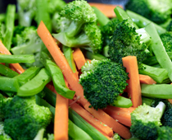](https://www.educationquizzes.com/library/KS1-Science/Where-does-food-come-from-5.jpg)

* Nuts
* Fruit
* Meats
* Vegetables

What is your favourite vegetable?

Paul likes eating shepherd’s pie. It has potato on the top and minced beef underneath. Where does the beef come from? _________________

[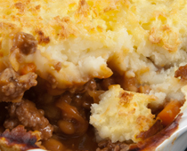](https://www.educationquizzes.com/library/KS1-Science/Where-does-food-come-from-4.jpg)

* Pigs
* Sheep
* Fish
* Cows

Beef is meat from cows and bulls. Some people call shepherd’s pie by another name. They call it cottage pie

What is bread made from? _________________

[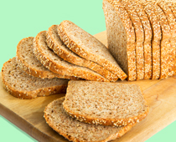](https://www.educationquizzes.com/library/KS1-Science/Where-does-food-come-from-9.jpg)

* Potatoes
* Rice
* Oil
* Flour

Yeast is also used. It makes the bread rise

Bananas, apples, oranges, grapes, pears, strawberries and blackberries all come from plants. They are all: ___________

[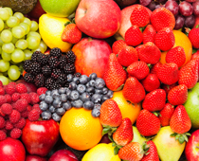](https://www.educationquizzes.com/library/KS1-Science/Where-does-food-come-from-6.jpg)

* Vegetables
* Meats
* Fruits
* Nuts

Which are your favourite fruits?

Alan likes cheese sandwiches. What is cheese made from?______________

[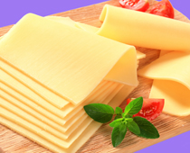](https://www.educationquizzes.com/library/KS1-Science/Where-does-food-come-from-3.jpg)

* Beef
* Beans
* Flour
* Milk

Milk, yoghurt, butter and cheese are all called dairy products

Where do potatoes grow?_________________

[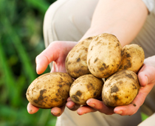](https://www.educationquizzes.com/library/KS1-Science/Where-does-food-come-from-8.jpg)

* In the ground
* On trees
* On leaves
* On bushes

Farmers plant potatoes in the spring. They harvest potatoes in the summer and autumn

Where does milk come from?__________________

[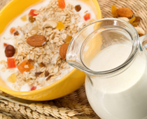](https://www.educationquizzes.com/library/KS1-Science/Where-does-food-come-from-1.jpg)

* Pigs
* Trees
* Factories
* Cows

Milk is sold in plastic cartons or in glass bottles

Where do eggs come from?___________________

[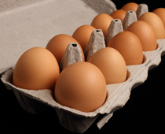](https://www.educationquizzes.com/library/KS1-Science/Where-does-food-come-from-7.jpg)

* Cows
* Pigs
* Plants
* Chickens

**The naming of Emain Mhaca**

It was a night that will live on in the memory of all of Ulaidh!

In my own mind I can still hear the sound of drumming hooves and the lighter thrumming of the autumn rain *(get audience to make sounds)*

For it was a night of rain when she arrived; and her movement was like the sound of hooves upon the lush meadows of Emain Mhaca!

Cruinniuc was a farmer in the northern part of Ireland back in the days of legend, and often legends are told of heroes and their mighty deeds, but this tale is about humbler folk who change the path of history nonetheless.

Like most of us, Crunniuc wasn’t a bad man but his life had been struck with ill fortune for years – his wife had passed away and he was left with young children to care for as well as a farm. No small task this, and he wasn't really up to it, so he became used to living in a rough household.

Then one day when he returned bone-weary from the fields, he was astonished to discover his home was clean and neat and with a good dinner cooking on the fire.

A beautiful woman with flaming red hair sat beside it stirring the stew, and she said she was called Macha, and had chosen to be his wife. As happy as he was amazed, Cruinniuc near danced with joy and agreed to let her stay.

Unlucky he might have been but blind he was not, although he didn't question his good fortune too closely, he couldn't help notice the way her feet barely touched the ground when she moved, and that she scarcely had to gesture at a broom and the kitchen would be clean. *(Act this out)*

One of the fair folk she was, to be sure, but as she was his wife he kept that to himself. As time passed she became pregnant and their happiness grew.

It happened that the King of Ulster was a keen charioteer, and he had bought a pair of new horses for their weight in gold. Proudly, he sent messengers throughout the land, summoning people to a great feast in his hall. Cruinniuc was delighted but before he set out, Macha put a geas on him, a holy forbidding, telling him that under no circumstances was he to speak of her, or it would end in disaster!

Of course Cruinniuc agreed and he went to join the rest of the people at the king's celebrations.

The king’s feasting hall was filled with all the greatest warriors of the land. There was great feasting and even greater drinking!

Men spoke with pride of the cooking of their wives, and of their beauty and grace, but Cruinniuc said nothing, being careful of how much he drank… *(Get members of audience to declare the following)*

‘My wife is the most beautiful in all of Ulaidh...’

‘Ah, but mine is from Connaught, home of Ireland’s most beautiful woman…’ etc… another said.

‘Nonsense, we all know my wife is the most fair!’

After the food the festivities continued outside where people gathered for the traditional horse racing.

Crunniuc watched as the two horses of the king carried off prize after prize in the racing, and the people cried

“There is not in Ireland anything swifter than the King's pair of horses.” *(All to repeat)*

Having taken a few cow-horns of mead, Cruinniuc said a bit too loudly that his wife could run quicker than those beasts, and who should be passing close by at that moment but the king himself!

‘My wife is swifter than any horse here!!!’

Filled with wrath, the king ordered him seized and his wife brought to the hall, and if she couldn't make good his boast, he'd have Cruinniuc's head off for his insolence.

Macha groaned with dismay when she saw the king's men riding up outside the house, but she agreed to go with them, despite it being near her time, and her heavy with child. When she stood before the king she begged him to forgive her foolish husband, and told all the men there that their mothers would weep to see them, but the king's heart was of stone.

Despite being a bit drunk himself, the king looked narrowly at Macha, for he could tell there was something uncanny about her, so he quietly had his chariot stripped down to the bare planks, and himself wore only a light cloak. They set up to race, the king and the weeping woman, outside the king's hall, and all the men of Ulster stood to watch.

*To the sound of hooves quickly*

Full as quick as a summer storm the king's chariot flew across the even grass, but no matter how quick he was, Macha was quicker! But as she ran her time came upon her, and she began to scream in anguish. The crowds fell silent, finding this entertainment suddenly no longer to their tastes, and Macha beat the king's horses by the breadth of her belly.

Collapsing to the ground, she gave birth to twins, neither of them alive, and herself perished shortly after. But before she went back to her own lands, she laid a terrible curse on the men of Ulster –

“From this hour the shame you have wrought on me will fall upon each man of Ulster. In the hours of your greatest need you shall be weak and helpless as women in childbirth, and suffer her pains, and this shall endure for five days and four nights – to the ninth generation the curse shall be upon you.”

And so it came to pass, and this weakness was used to cause great harm to the men of Ulster for years to come.

And this is how Emain Mhaca got its name…for it is named after the twins of Mhaca!!

*Complete the exercise with the words below*

_________ ____________ is the ancient capital of Ulster. It is also home of the ______ Branch Knights. This elite school trained the greatest warriors in the land, the most famous of which was called ____ __________.

During the _________ Age, the ______ moved from central Europe into Ireland. They lived in __________ houses, in family units called ________. Each clan had a great ________ who ate the largest portion of the meat at meals. There were also potters, wood-turners and druids.

There were three different types of druids: ___________, ______________, and____________ ___________.

Bards

Vates

Emain Mhaca

Red

Iron

Cu Chulainn

Celts

Warrior

Brehon lawgivers

Round

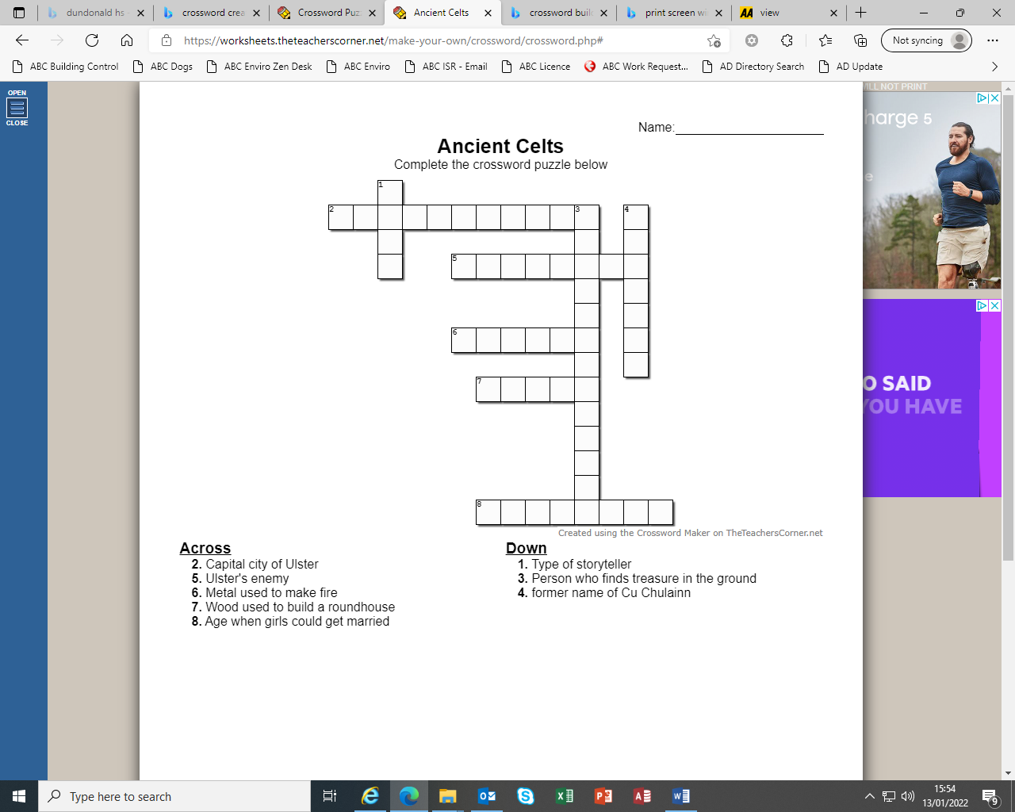

**Artefact Quest**

Studying the artefacts in the pictures below work together in your group to answer the following questions. All of the artefacts were used and made during the three periods below.

**STONE AGE BRONZE AGE IRON AGE**

Write your answers in the sections provided.

**Name:** _____________, ______________, ________________, ________________, ______________

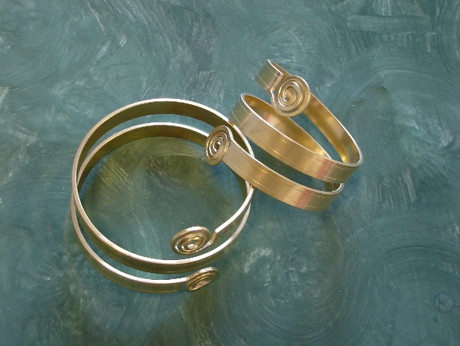

**1.** Worn by both adults and children, during what period would these beautiful artefacts have been made?

1

­­­­­­­­­­­­­­­­______________________________

What material are they made from?

______________________________

Can you name the people who wore and designed these artefacts?

______________________________

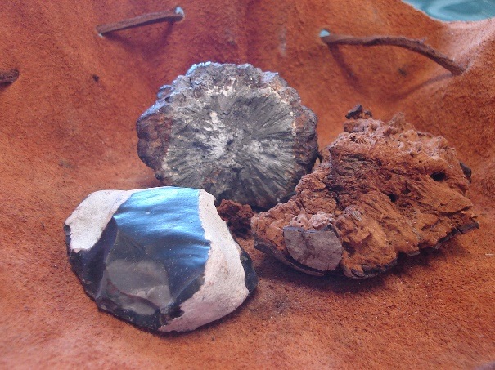

**2.** This set of artefacts was very important to early man.

2

Can you name the items? ________________

________________

________________

What was this set used for?

_____________________________________

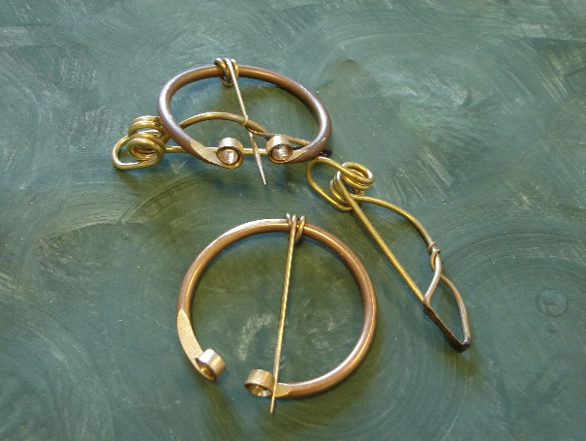

3

**3.** When the first metals were discovered people began to create beautiful jewellery to wear on their clothes.

What period would these brooches have been made?

____________________________________________

Can you remember which two metals are used to make these pieces?

__________________

__________________

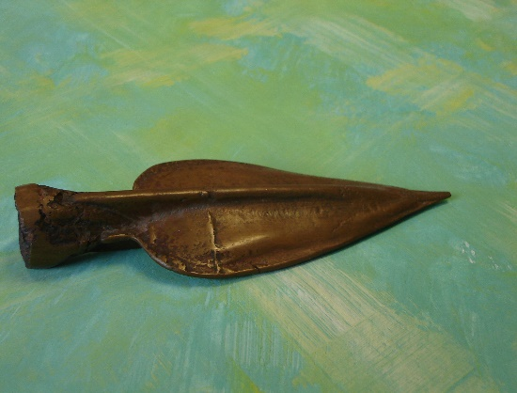**4.** What would the artefact in picture four be used for?

4

________________________________

During this period this metal was used mostly in ceremonial weapons.

Looking at its colour what metal has been used?

_____________________________________

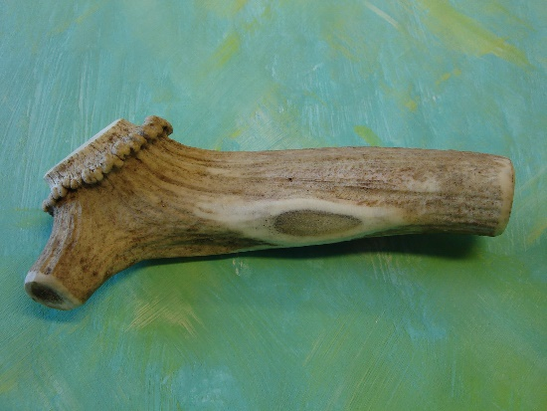

5

**5.** Picture five shows an artefact used by early man during the Stone Age period.

What would this artefact have been used for?

____________________________________

What is it made from?

__________________________

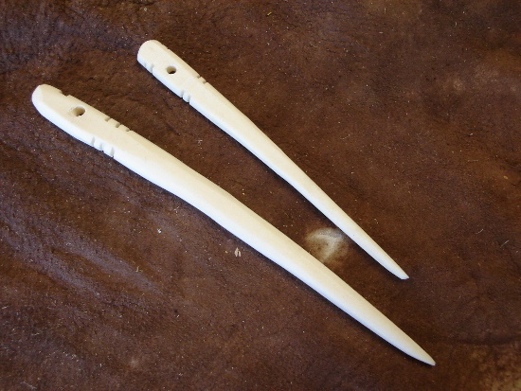

**6.** What would the artefacts in picture six be used for?

_________________________________

Can you name the material used to make these items?

_________________________________

6

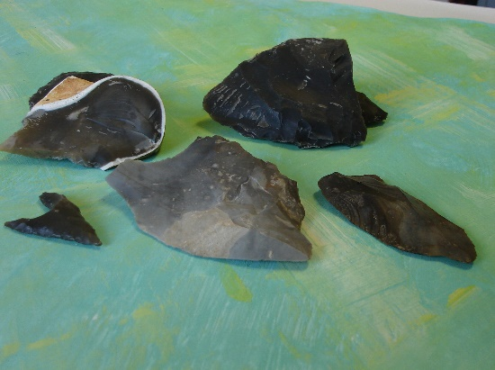

**7.** This material was used throughout the Stone Age, Bronze Age and Iron Age.

Can you name this material?

______________________

Can you name three things this material was used for?

1. ____________________

7

2. ____________________

3. ____________________

8

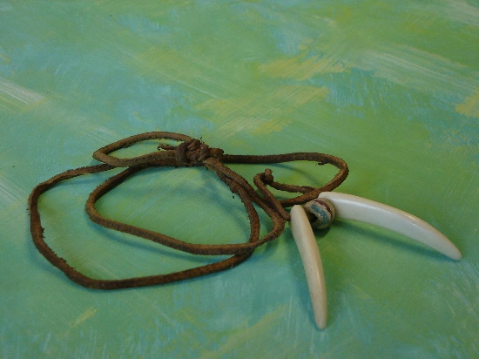**8.** Celtic warriors loved to dress up for battles, paint their bodies and spike up their hair to frighten their enemies. They also wore jewellery around their necks made from different materials.

Looking at the necklace in picture eight write down what materials you think this necklace is made from.

____________________________________________

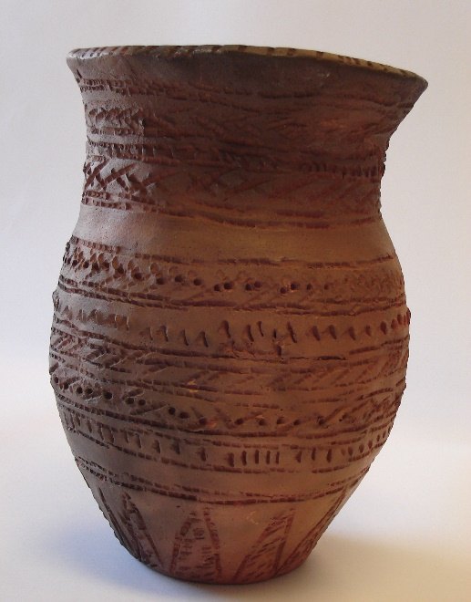

**9.** Picture nine shows a piece of pottery with hand-made decoration around the sides.

What period do you think this pottery vase comes from?

Tick the box you think is correct.

**Stone Age**

**Bronze Age**

**Iron Age**

9

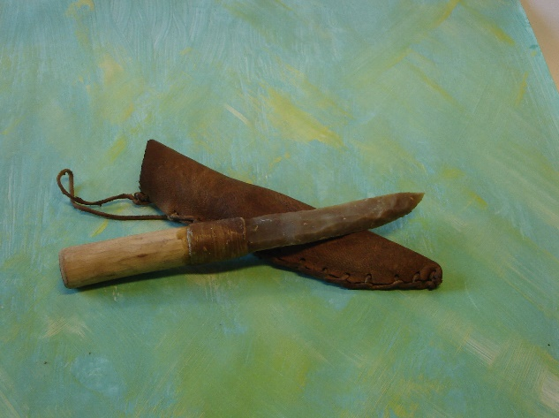

**10.** Picture 10 shows a knife made during the Stone Age.

10

What two materials are used to make this knife?

_____________________________________

What material has been used to make the scabbard or cover for the knife?

_____________________________________

Can you remember what material is used to join the blade and handle of the knife together?

____________________________

**Well done, now let’s see if your group has all the correct answers.**

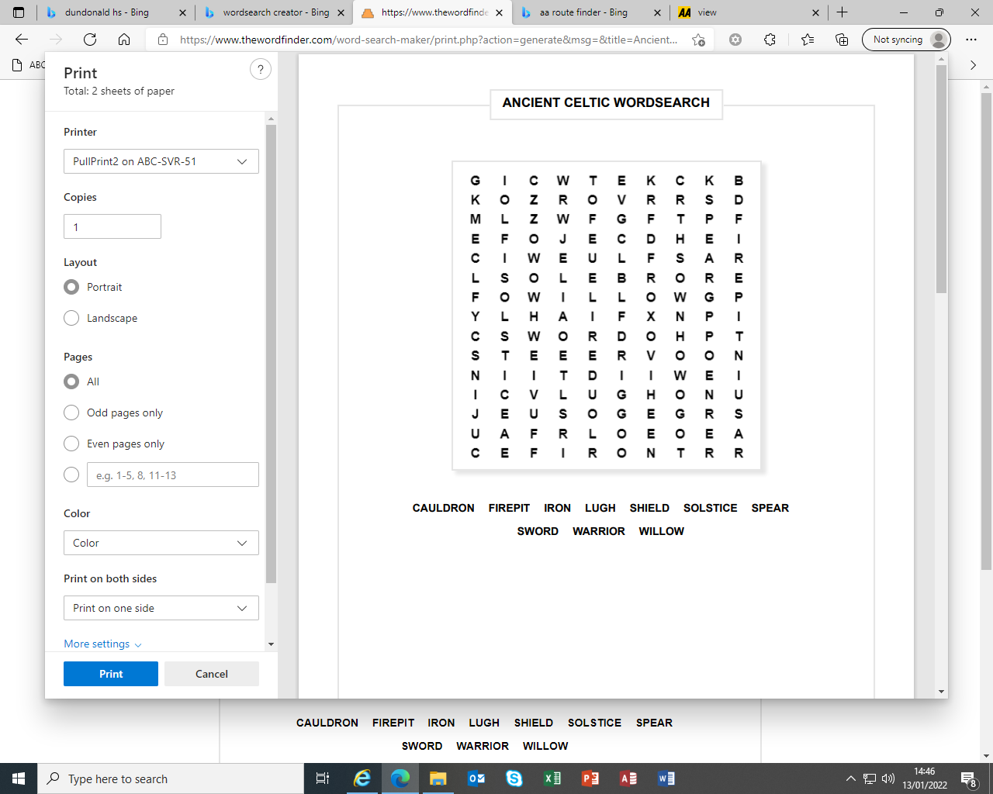

*Use the word bank below to write a short paragraph on your visit to the Navan Centre*

MY FAVOURITE THING WAS…

I PREFERRED…

ARCHAEOLOGY

‘DETECTIVE OF THE PAST’

CELTS

ARTS AND CRAFTS

ALAN/PAUL/SYLVIA/DARA/FERGAL

ARTEFACTS

PYRITE

BEAKER

__________________________________________________________________________________________________________________________________________________________________________________________________________________________________________________________________________________________________________________________________________________________________________________________________________________________________________________________________________________________________________________________________________________________________________________________________________________________________________________________________________________________________________________________________________________________________________________________________________________________________________________________________________________________________________________________________________________________________________________________________________________________________________________________________________________________________________________________________________________________________________________________________________________________________________________________________________________________________________________________________________________________________________________________________________________________________________________________________________________________________

**A Day in the life of a Celt**

*Below are some activities the Celts might have done during their day. Use them to create a diary entry for a day of your life if you were a Celt. You do not have to use all of them.*

Sweep the floor.

Collect water from the stream for drinking and washing.

Help prepare breakfast.

Work in the field.

Get up when the sum wakes you.

Feed the chickens.

Weave cloth.

Dye yarn.

Decorate a new cooking pot.

Polish helmet.

Repair roof of roundhouse.

_____________________________________________________________________________________________________________________________________________________________________________________________________________________________________________________________________________________________________________________________________________________________________________________________________________________________________________________________________________________________________________________________________________________________________

Celtic Life

*Sort the following statements into true or false about the everyday lives of the Celts.*

The houses were made from brick and had metal front doors.

The houses had no windows.

The Celtic people lived in long wide houses

Called Longhouses.

The Celtic times were also known as the Iron Age.

The houses were made from straw, wood and mud.

The children had to help with all of the family chores.

The women weaved all of the cloth and made the clothes for the family.

The Celts were warriors but also very good farmers.

They grew all of their own food and kept animals such as sheep and chickens.

The houses were round in shape and were one large room- called a Roundhouse.

The Celtic people lived in small settlements of round houses grouped together.

They cooked their food on open fires.

The Celts used bronze and gold as well as iron. The heads of the tribe would wear fancy jewellery to show how important they were.

The Celts would light a fire in the middle of the roundhouse for cooking and heating.

Men would wear a tunic with a belt, a cloak and trousers. Women wore dresses fastened with brooches.

The Iron Age Celts lived in Britain before and after Jesus. We're going back a very, very long time - two thousand years ago.

The Celts used berries and plants to dye the wool different colours.

The houses had central heating.

The Celts lived in large cities.

They travelled around by car.

The Celtic people believed in one God.

The men painted their bodies with colourful patterns.