Please return by email or post with the appropriate SUPPORTING MATERIALS by 5pm, Monday 4 March 2024 to The Creative Programme Development Manager, Armagh Craft Fair, Market Place Theatre and Arts Centre, Market Street, Armagh, Co Armagh BT617BW
E: christine.donnelly@marketplacearmagh.com

SECTION 1: Your Details
Contact Name:

Name of Business/Practice:

Address:

Postcode:

*Mobile:

*Email:

Website:
Socialmedia addresses:

Craft Product/Discipline:

Description of your work: This description may be used in Armagh Craft Fair 2024 PR so make sure to choose your selection of words carefully. Do not exceed 10 words.

SECTION 2: Stand Requirements |  | YES |  | NO
Please indicate if you require a table to be provided for your stand

If you are taking multiple stands please indicate the number of tables required (Payment is required for each table requested)
Please indicate if you require an electrical socket to be provided

SECTION 3: Demonstrations (please tick) | YES | NO
Are you applying to provide a demonstration/s at Armagh Craft Fair 2024?
Please describe what you would be willing/able to demonstrate. This is a competitive process so make sure to give as much information as possible to sell it to us… We are particularly looking for demonstrations that children and adults can gain hands on experience with. However we are also interested in demonstrations that are interesting/exciting to watch. Please note; Demonstrations continue throughout the day. You must be available to engage with the public all day. If you take a stand then you will be required to have another person manage your stand while you demonstrate on a separate stand/area. Demonstrations are stand alone and fee paid. Demonstrators may not sell products unless they have paid the stand fee.

SECTION 4:  Supporting Materials for ALL APPLICANTS (please tick) | YES | NO
Enclosed: Cheque or Postal Order for the amount of £50.00 or payment by debit/credit card on line or via box office 03300561025
https://marketplacearmagh.ticketsolve.com/ticketbooth/shows/873643394
Cheques made payable to: Armagh City, Banbridge and Craigavon Borough Council
*Enclosed: Copy of your Public Liability Insurance Policy
*Enclosed: EU Cosmetic Assessment (stall holders selling handmade cosmetics, soaps, bathbombs, creams, body products)
*Enclosed: Hygiene certificates and Food safety certificates if selling edible products.
Enclosed: Up to 4 high quality images by email. Files should not exceed more than 1MB per image.
Please do not send images via wetransfer, dropbox, Google Drive or other file sharing sites. No pen drives accepted.

I wish to apply for participation in the above event and agree to pay the appropriate costs by the stated deadline. I, the undersigned, hereby indemnify Armagh City, Banbridge and Craigavon Borough Council and its employees against any injury to, or the death of any person or any loss or damage to any property or any claim, demand proceedings, charge, costs or liability arising in connection with my participation in the project known as Armagh Craft Fair 2024. I confirm that all work has been made by me (where appropriate) and that I have the necessary insurance to take part in this event. I have enclosed a copy of my Insurance Policy.

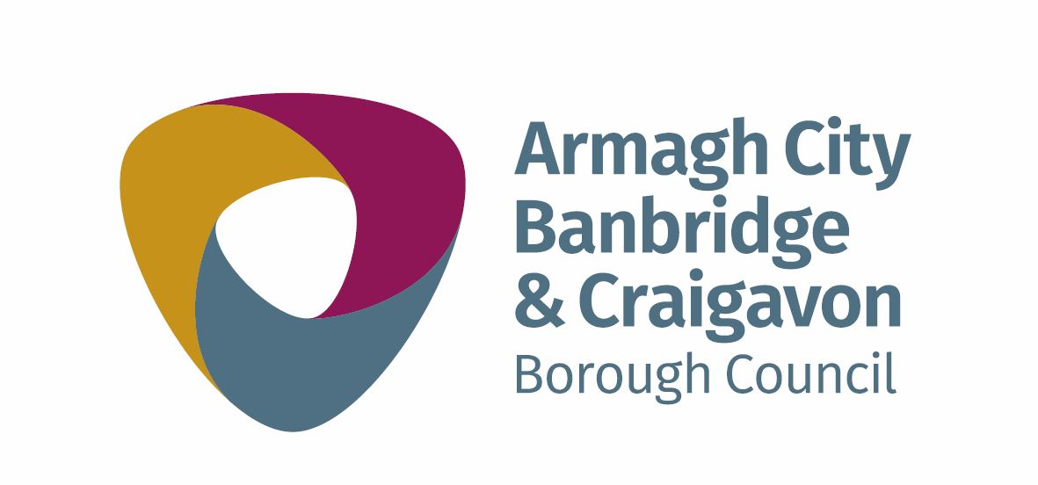
SIGNED: _________________________________________ DATED: _____________________________

