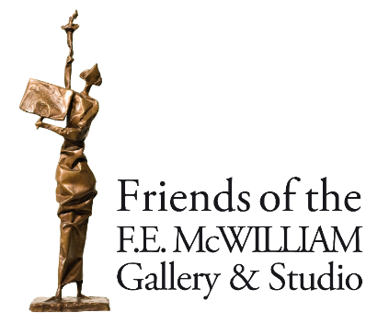

**ANNUAL GENERAL MEETING**

**Friends of the F.E. McWilliam Gallery & Studio**

**Meeting at 7pm for 7.30pm on Wednesday 15 May 2024**

**F.E. McWilliam Gallery & Studio, 200 Newry Road, Banbridge**

**Agenda**

**Tea & coffee on arrival and membership renewal service available**

1. Welcome
2. Apologies
3. Adoption of minutes AGM 2023
4. Annual Report inc Accounts
5. Election of Committee
6. Questions for Committee
7. Any Other Business

Talk by artist, Anushiya Sundaralingham

Charity Registration No NIC 106019